Lesson 2 Demo 2: Configure Docker Daemon to Start on Boot

This section will guide you to:

* Configure Docker Daemon to start on the system boot

**Step 1:** Start the docker service, using *systemctl* commands for Ubuntu 16.04 and above

versions

* Use the following command to enable Docker Daemon on the boot:

*sudo systemctl enable docker*

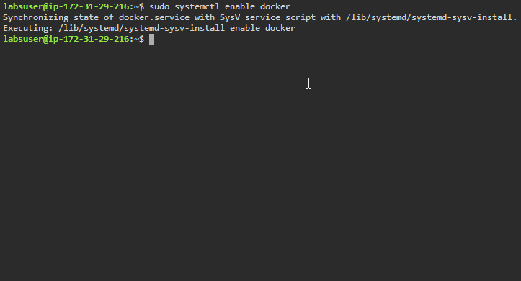

* Use the following command to disable Docker Daemon on the boot:

*sudo systemctl disable docker*

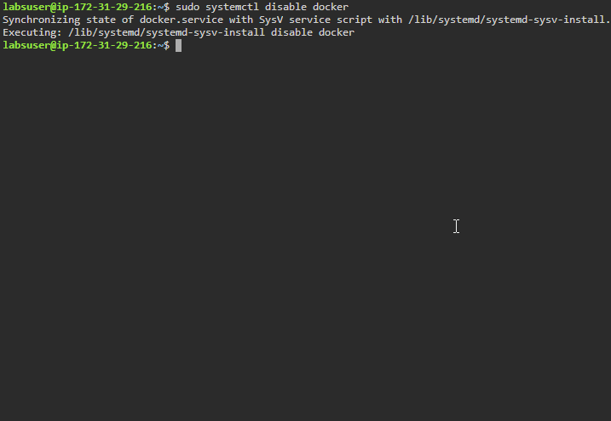

* Use the following command to reload Docker Daemon:

*sudo systemctl daemon-reload*



**Step 2:** Start and configure docker service using upstart command for Ubuntu 14.10 and below versions

* Use the following command to disable Docker start on the system boot:

*echo manual | sudo tee /etc/init/docker.override*

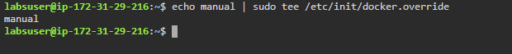

**Step 3:** Create a *daemon.json* configuration file to configure the Daemon flags and

environment variables

* Use the following command to move to /etc/docker/ folder:

*cd /etc/docker/*



* Use the following command to create the *daemon.json* file:

*sudo vi daemon.json*



* Set the following flags to control the disk space for Docker images and containers:

{

"data-root": "/mnt/docker-data",

"storage-driver": "overlay2"

}

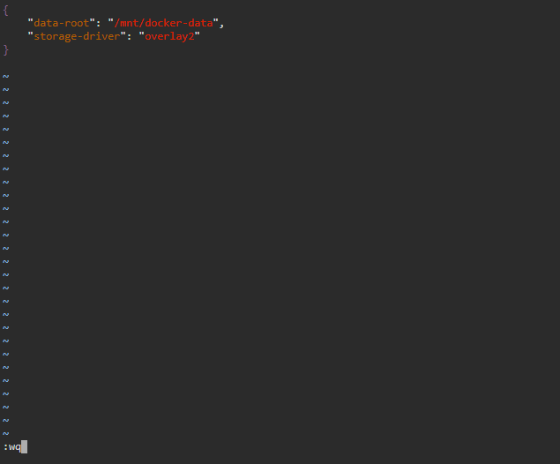

**Note:** After writing the above code in the *daemon.json* file, press the ESC button and type **:wq** to save the file and exit the editor.